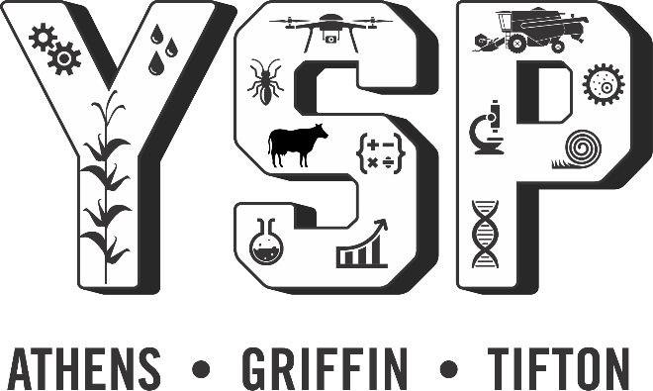

Young Scholar Outline

- YSP Links
- Hear what other kids think about YSP
- Hear why UGA faculty love YSP
- Look at their graduation video on YouTube
- See what the class of 2023 plans will look like
- See the dates for the class of 2023
- See the link to the application
- YSP Majors and Choices
- See what Majors to choose from as an internship
- Research that department
- Look up the professors and think about whether you’d like to intern with them
- What can I do with my Degree
- See what a career in those fields looks like

Young Scholar Links
UGA YSP student videos
See what other students are saying:
- https://youtu.be/ylf1xvOMxpQ
UGA Professors love YSP
See why UGA professors love YSP:
- https://youtu.be/n-YceInEtPQ
Orientation
View YSP Class of 2023 information here:
- In-depth overview class of 2023
Graduation
View YSP Graduation Class of 2022 here:
- https://www.youtube.com/watch?v=H8_Jp_aC3dM
Application
Apply here:
- https://www.caes.uga.edu/students/prospective-students/youth-high-school-programs/young-scholars.html

Application information:

Acceptance: 25 students (10 residents – 15 commuters) 2-3 students per high school accepted.
• Application opens for submissions: November 1, 2022
• Application submission deadline: January 31, 2023
• Interviews March 13,16,20,23
• Selection notification: April 1, 2023
• YSP Move in & Orientation May 31, 2023
• YSP Welcome BBQ with Deans, lab mentors etc. June 1, 2023
• YSP Conference and ceremony July 12 - July 14

Young Scholar Majors and Choices
****All headings are hotlinks to direct you to learn more****

Academic Departments at CAES

Agricultural & Applied Economics
The Department of Agricultural and Applied Economics is home to 30 core faculty members and other adjunct faculty and staff members across three campuses who conduct research in agricultural, food, environmental, natural resource and development economics.
Agricultural Leadership, Education & Communication
The Department of Agricultural Leadership, Education and Communication promotes food, environmental and social sustainability through experiential education.
Animal & Dairy Science
The Department of Animal and Dairy Science provides instructional, research and Extension programming relating to food animals and livestock, companion animals, and animal and medicinal biotechnology that addresses critical issues in today's world.
Crop & Soil Sciences
The Department of Crop and Soil Sciences is a multifunctional, multidisciplinary department committed to excelling as an authority in the crop, soil and environmental sciences.
Entomology
The Department of Entomology offers a wide range of courses and research opportunities for undergraduate and graduate students. If you're interested in insect biology, learn more about these programs.
Food Science & Technology
Food scientists conduct research in several areas critical to the quality, safety, and economic value of our food supply, while minimizing environmental and energy costs. Learn more about this department.
Horticulture
The Department of Horticulture specializes in a multitude of research areas and works on a vast array of fruit, vegetables, ornamentals, endangered native species and row crops.
Plant Pathology
As one of the largest departments of plant pathology in the country, we are recognized internationally for our comprehensive and integrative research and outreach portfolio, spanning basic, translational and applied programs.
Poultry Science
The Department of Poultry Science boasts some of the best undergraduate programs of its kind, while preparing its students for some of the top jobs in the poultry industry or further degrees.

2023 partnerships
Each year the College of Agricultural and Environmental Sciences partners with other departments to provide more internship choices. The 2023 additional choices are as follows:

  - Veterinary Medicine
  - College of Engineering
  - Warnell School of Forestry

What can I do with my Degree?
****All headings are hotlinks to direct you to learn more****

Agricultural & Applied Economics
https://career.uga.edu/wcidwami/agricultural_and_applied_economics
- Economic Development Coordinator
- Banker
- Account Executive
- Investment Consultant
- Marketing Director
- Sales Representative
- Economist
- Environmental Protection Specialist
- Business Owner
- Business Analyst
- Consultant
- Economic Analyst
- Environmental Manager
- Environmental Planner
- Chief Financial Officer
- Business Manager
Agricultural Leadership, Education & Communication
https://career.uga.edu/uploads/documents/wcidwami/Agricultural%20Communication.pdf
- Admissions Counselor*
- Advertising
- Agricultural Consultant
- Agricultural Marketer
- Customer Relations
- Editor*
- General Manager*
- Graphic Design
- Information Specialist*
- Insurance Sales
- Marketing Specialist*
- Photographer
- Production Coordinator*
- Project Coordinator*
- Public Relations
- Real Estate
- Reporter
- Retail Sales
- Sales and Promotion
- Sales Trainee*
- Writer
Animal & Dairy Science
https://career.uga.edu/wcidwami/animal_science
- Veterinarian
- Veterinary Technician
- Wildlife Rehabilitator
- Animal Behaviorist/Animal Trainer
- Humane Educator
- Lobbyist/Lawyer
- Zoologist
- Marine Biologist
Crop & Soil Sciences
Careers in Crop and Soil Sciences
- Agroecology Specialist
- Conservationist
- Extension Agent
- Restoration Specialist
- Agronomist
- Crop Advisors
- Plant Breeder
- Soil Scientist
- Athletic Turf Manager
- Environmental Specialist
- Precision Agriculture Specialist
- Waste Management Specialist
Entomology
https://career.uga.edu/wcidwami/entomology
- Private Sector: agricultural industries, production (green industry, seed companies, plant breeding enterprises),
- Federal and State Agencies: military (vector-borne diseases, quarantine facilities, sanitation of facilities, food, and vehicles); federal research laboratories (CDC, USDA, USDI, USFS, EPA, NIH, USGS); state departments of agriculture (pesticide industry regulations and educational programs, introduction of new species); state departments of natural resources (conservation biology, invasive species, environmental biology); state, county and city departments of health (public health concerns, vector control programs, protective programs for pets and people); extension services (educational programs for commodity areas, educational programs for human and animal health issues); federal and state regulatory agencies (USEPA, USFDA, USDA-APHIS, Georgia Environmental Protection Division, county and municipal governments); academic institutions (research and teaching universities, two-year colleges, community and technical colleges).
- Non-Governmental Organizations: museums, botanical gardens, butterfly houses and zoos.
Food Science & Technology
https://career.uga.edu/wcidwami/food_science
- Food Processing
- Food Microbiology
- Food Chemistry
- Food Engineering
- Nutritional Quality
- Instrumental Methods of Food Analysis
- Food Quality Control;
- Governmental Regulation of Food Safety and Quality
- Food Packaging
- Food Fermentations
- Food Biotechnology
- New Food Product Development
- Hazard Analysis and Critical Control Point
Horticulture
https://hort.caes.uga.edu/

https://career.uga.edu/wcidwami/horticulture#:~:text=Horticulture%20graduates%20find%20jobs%20in,restoration%2C%20and%20medicinal%20herb%20cultivation.
- Landscaping
- Nurseries
- Research
- Horticultural Therapy
Plant Pathology
https://plantpath.caes.uga.edu/
https://career.uga.edu/wcidwami/plant_biology
- Educational institutions
- Federal and state agencies
- Industry
Poultry Science
https://poultry.caes.uga.edu/
https://career.uga.edu/wcidwami/poultry_science
Careers in poultry science include:
- Agricultural Production
- Avian Animal Trainer and Caretaker
- Avian Biologist
- Avian Research Technician
- Avian Writer and/or Photographer
- Biologist
- Breeding Supervisor
- Broiler Manager
- Career in Poultry or Animal Agriculture
- Complex Compliance Officer
- County Extension Agent
- Dentistry
- Exotic Bird Breeder
- Feed Inspector
- Flock Supervisor
- Food Scientist
- Government Agencies
- Hatchery Manager
- Human Medicine
- Lab Technician
- Laboratory Research and Development
- Pharmaceuticals
- Poultry Specialist
- Production Manager
- Quality Assurance Management Trainee
- Turkey Grower
- Veterinary Medicine
- Vocational Agriculture Teacher

